**React HOL 2**

React components are the building blocks of a React application UI. They are JavaScript functions or classes that return JSX and manages their own login and state.

**Difference Bw Components and JavaScript Functions**

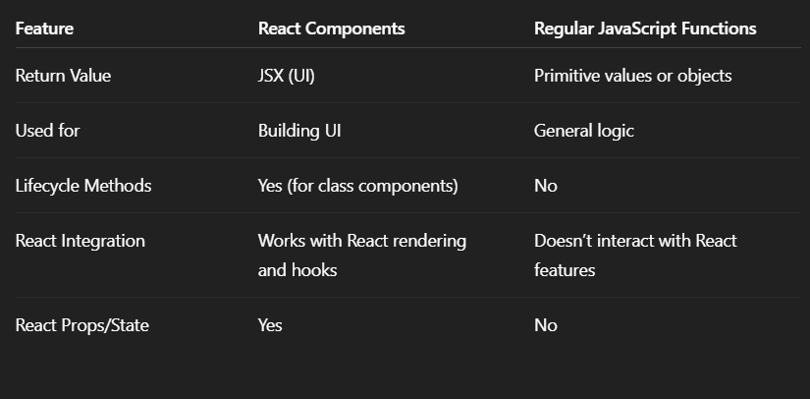

**Types of Components in React**

1. Class Component
2. Function Component

**Explanation of Class Component**

A **class component** is a React component defined using an ES6 class that **extends** React.Component.

Must define a render() method.

**Explanation of Function Component**

A function component is a simpler way to write components using a plain JavaScript function.

Returns JSX directly.

**Define Component Constructor**

In class components, the constructor method is used for:

1. Initialize state
2. Bind event handlers

**render() function:**

The render() method is required in class component.

It returns JSX that should be displayed on the screen

App.jsx

import Home from './Components/Home'

import About from './Components/About'

import Contact from './Components/Contact'

import './App.css'

function App() {

  return(

    <div className = "container">

      <Home/>

      <About/>

      <Contact/>

    </div>

  )

}

export default App

Home.jsx

import React, { Component } from 'react';

class Home extends Component {

    render() {

        return (

            <div>

                <h3>Welcome to the Home Page of Student Management Portal</h3>

            </div>

        );

    }

}

export default Home;

About.jsx

import React, { Component } from 'react';

class About extends Component {

    render() {

        return (

            <div>

                <h3>Welcome to the About Page of Student Management Portal</h3>

            </div>

        );

    }

}

export default About;

Contact.jsx

import React, { Component } from 'react';

class Contact extends Component {

    render() {

        return (

            <div>

                <h3>Welcome to the Contact Page of Student Management Portal</h3>

            </div>

        );

    }

}

export default Contact;

